006BC2744 - Day 15 (5 August 2026)

Task 1: What is angular? Explain briefly.

Angular is a TypeScript-based web framework developed by Google for building dynamic, single-page web applications (SPAs).
It provides features like components, routing, forms, HTTP services, and dependency injection to create scalable frontend applications.

Task 2: What is data binding? Explain.
How many types of data bindings do you have .. can you explain them.

Data binding is the mechanism in Angular that connects the component (TypeScript) with the HTML template, allowing data to flow between them.

There are 4 types of data binding:

- Interpolation: {{name}} — displays component data in HTML.
- Property binding: [src]="imageUrl" — binds a property from component to HTML.
- Event binding: (click)="onClick()" — sends events from HTML to the component.
- Two-way binding: [(ngModel)]="name" — synchronizes data in both directions.

Task 3: Why do you need Angular? Can you give some advantages of using angular with description.

Angular is useful for building dynamic, scalable, and maintainable web applications, especially single-page applications (SPAs).

Advantages:

- Component-based: Reusable components make development and maintenance easier.
- Two-way data binding: Keeps the UI and application data synchronized.
- Built-in features: Provides routing, forms, HTTP services, and dependency injection.
- TypeScript support: Provides strong typing and better code organization.
- Scalable: Suitable for both small applications and large enterprise applications.

Task 4: What is Rest API?

A REST API (Representational State Transfer API) is a way for applications to communicate over HTTP using methods such as GET, POST, PUT, and DELETE.
It allows clients and servers to exchange data, usually in JSON format, through resource-based URLs.

Task 5: Why do we use Rest API?

We use REST APIs to allow different applications, such as an Angular frontend and a Node.js backend, to communicate and exchange data over HTTP.
They provide a simple, standardized way to create, read, update, and delete (CRUD) resources using HTTP methods like GET, POST, PUT, and DELETE.

Task 6: What are single Page Applications?

Single Page Applications (SPAs) are web applications that load a single HTML page and dynamically update its content without reloading the entire page.
Frameworks like Angular use SPAs to provide a faster, smoother, and more interactive user experience.

Task 7: Explain modules, components and services in Angular.

- Modules: Organize related Angular functionality into logical groups. In modern Angular, standalone components can reduce the need for traditional NgModules.
- Components: The building blocks of Angular UI, containing a TypeScript class, HTML template, and styles.
- Services: Reusable classes that contain business logic or shared functionality, such as calling REST APIs or managing data.

Task 9: What Are Decorators? Explain types of decorators.

Decorators are special TypeScript functions that add metadata or modify the behavior of classes, properties, methods, or parameters.

Common Angular decorators include:

- Class: @Component, @Injectable, @Directive, @Pipe
- Property: @Input, @Output
- Method: @HostListener
- Parameter: @Inject

Task 10: What are annotations in angular?

In Angular, annotations are metadata added to classes to tell Angular how they should be used or processed.
For example, @Component() provides metadata such as the component’s selector, template, and styles; in Angular, these are implemented using TypeScript decorators.

Task 11: In the below code snippet what are we doing .. Can you explain..

// parent component
import { Component } from '@angular/core';
@Component({
selector: 'app-parent',
template: `
<app-child [childMessage]="parentMessage"></app-child>
`,
styleUrls: ['./parent.component.css']
})
export class ParentComponent{
parentMessage = "message from parent"
constructor() { }
}
// child component
import { Component, Input } from '@angular/core';
@Component({
selector: 'app-child',
template: `Say {{ childMessage }}`,
styleUrls: ['./child.component.css']
})
export class ChildComponent {
@Input() childMessage: string;
constructor() { }
}

This code demonstrates parent-to-child data binding in Angular using the @Input() decorator.

Task 12: Can you create a typescript class with a constructor and a function.

class Student{

name?: string;
age?: number;

constructor(name: string, age: number){

this.name = name;
this.age = age;
}

displayDetails(): void{

console.log("Name: ", this.name);
console.log("Age: ", this.age);
}
}

let s1 = new Student("Bharggav", 25);

s1.displayDetails();

Task 13: There is something called eager loading. What do you mean by eager and lazy loading?

Eager loading means loading required data/resources immediately, even if they may not be needed right away.
Lazy loading means loading data/resources only when they are actually needed, which can improve initial application performance.

Task 14: What is an observable response?

An Observable response is a response that delivers data asynchronously over time using an RxJS Observable, rather than returning the data immediately.
In Angular, HttpClient commonly returns Observables, which allow you to subscribe and receive API responses when they arrive.

Task 15: What is the flow of your Angular project.. Explain with an ex.

The Angular project flow is: index.html → main.ts → AppComponent → routing → component → service → REST API.
For example, when /accounts is opened, Angular loads AccountComponent, which calls AccountService; the service requests data from the backend and the component displays the response in the HTML template.

Task 16: Create a fundtransfer.service.ts

Services & Dependency Injection in Angular
in service layer
Encapsulate business logic (e.g., fund transfers, notifications).
so that it promotes reusability across multiple components.
and will also enable loose coupling by separating logic from UI.

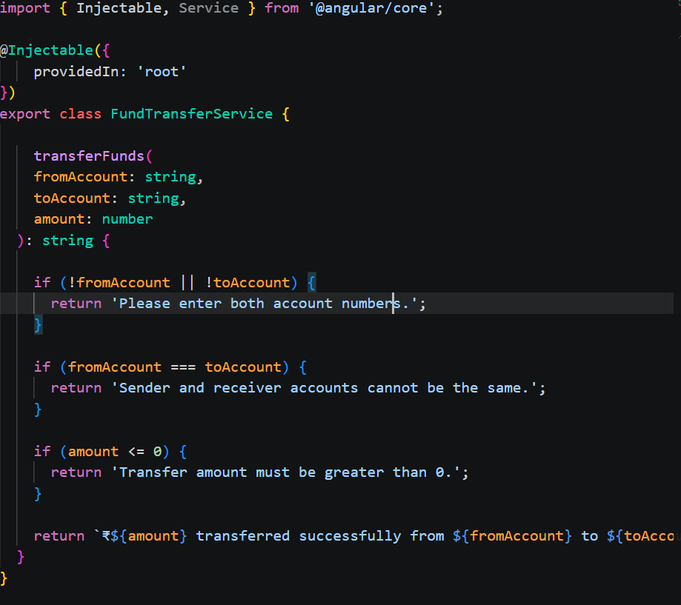

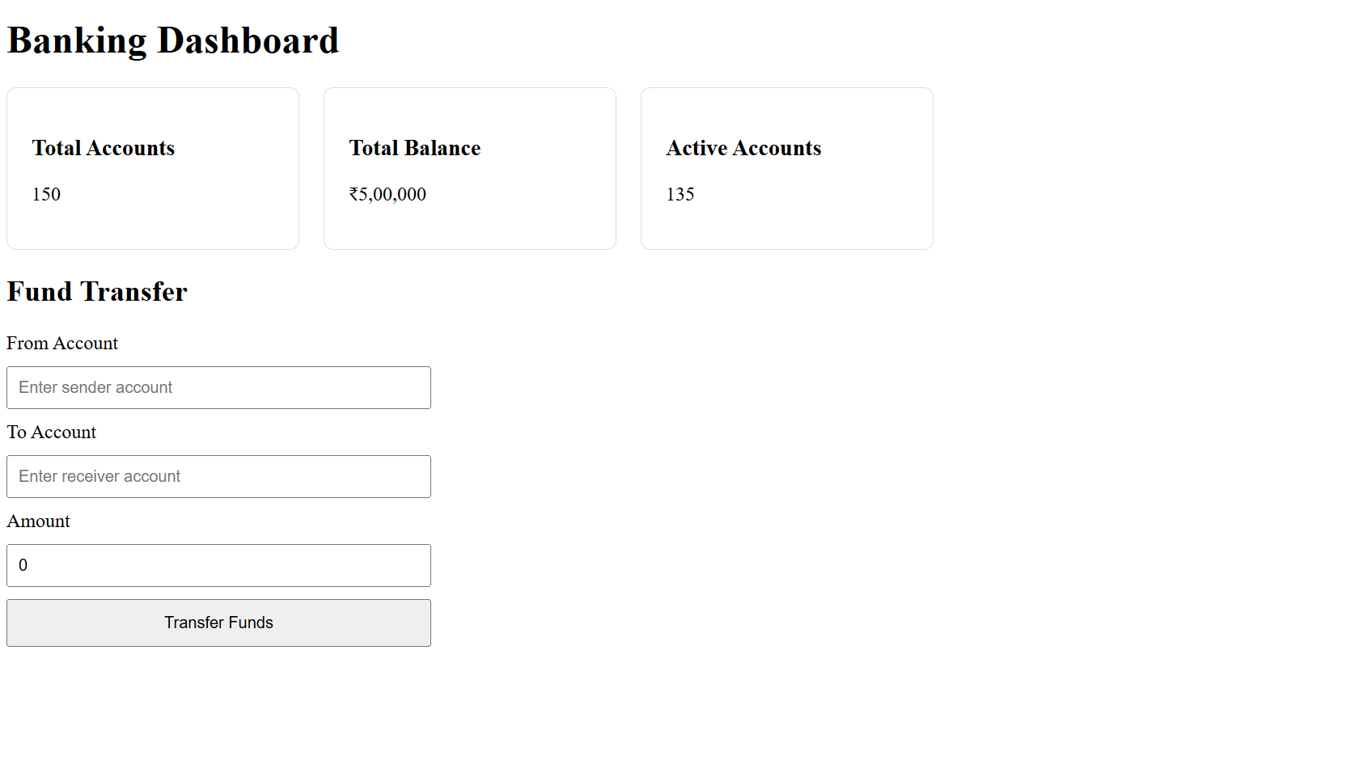

create a form component… say loginform.

Validation ensures users don’t transfer less than ₹100.
You can add async validators (e.g., check if account exists via API).
🔹 Advanced Features
FormArray → For multiple beneficiaries.
Custom Validators → e.g., prevent transfer to the same account.
Async Validators → e.g., check account balance before transfer.
Dynamic Forms → Add/remove fields at runtime.

